
TAMPINES JUNIOR COLLEGE

Preliminary Examinations 2009

CHEMISTRY (Higher 1) 8872/2

PAPER 2

Friday 4 Sept 2009 2 Hours

Additional materials: Writing Paper
Data Booklet

INSTRUCTIONS TO CANDIDATES
Write your name and Civics Group on all the work you hand in.
Write in dark blue or black pen.
Section A
Answer all questions in the space provided.
Section B
Answer two questions on separate answer paper.
At the end of the examination,
- fasten the answers to Section B to this cover sheet
- hand in the answers to Section A and Section B separately.
The number of marks is given in brackets [ ] at the end of each question or part question.
Name : ___________________________________  CG : ________ | Question | Marks
Name : ___________________________________  CG : ________ | Section A
Name : ___________________________________  CG : ________ | B7
 | B8
 | B9
 | TOTAL | / 80

This document consists of 15 printed pages.
Name: __________________________________ CG: ________
______________________________________________________________________
Section A: Structured Questions
[Total: 40 marks]
Answer all questions in this section in the spaces provided.
Question 1 [5 marks]
Ethandioate ions, C₂O₄²⁻, are oxidized to carbon dioxide by 0.020 moldm⁻³ acidified aqueous potassium manganate (VII), KMnO₄.
C₂O₄²⁻ → 2CO₂ + 2e⁻
- Using relevant half equations from the databooklet and the one above, write down the overall balanced equation for this redox process. [1]

_______________________________________________________
(b) Calculate the number of moles of ethandioate ions present in 0.22g of the salt, KHC₂O₄∙H₂C₂O_{4.} [Mr of salt = 218.1] [2]

(c) Hence, calculate the volume of KMnO₄ required to oxidize 0.22g of KHC₂O₄∙H₂C₂O₄ completely? [2]

Question 2 [6 marks]
A distinct trend is observed in the 1st ionization energies of elements in the same period.
(a) Define by means of an equation (including state symbols) what is meant
by the term 1st ionization energy of sodium metal. [1]

___________________________________________________________

(b) State and explain the trend of the 1st ionization energies across the period sodium to argon.
___________________________________________________________
___________________________________________________________
___________________________________________________________
___________________________________________________________
___________________________________________________________
___________________________________________________________
___________________________________________________________

- The graph below shows the variation in ionization energies for the outermost 8 electrons in an atom of the element X.
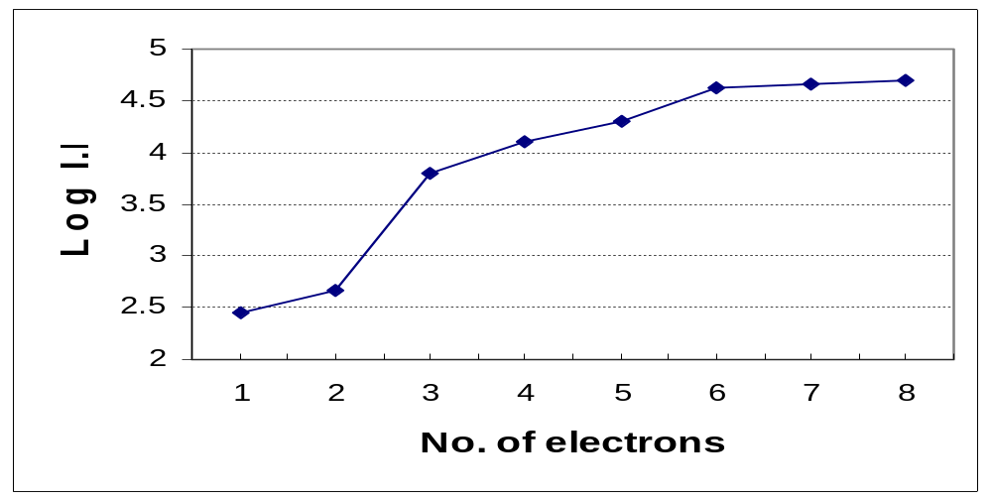
State, giving reasons, to which group element X belongs to? [2]
___________________________________________________________
___________________________________________________________
___________________________________________________________
___________________________________________________________

(d) Hence, draw a dot-and-cross diagram for the compound formed between chlorine and element X. [1]

Question 3 [7 marks]
Aqueous solution of chrominum (VI) ion exists in equilibrium in 2 different forms as shown below.
2CrO₄²⁻ (aq) + 2H⁺ (aq) 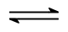 Cr₂O₇²⁻ (aq) + H₂O(l)
yellow orange
(a) Define Le Chatelier’s Principle [1]

___________________________________________________________
___________________________________________________________
___________________________________________________________

(b) Explain the effect and state any color change when a small amount of NaOH(aq) is added to the equilibrium mixture. [2]

___________________________________________________________
___________________________________________________________
___________________________________________________________

- An experiment was carried out with initial values of 0.4 mol CrO₄²⁻ (aq), and 0.3 mol of HCl (aq) in a 1 dm³ reaction vessel.
After some time, equilibrium of CrO₄²⁻ (aq) and Cr₂O₇²⁻(aq) was established at a fixed temperature. It was found that 62.5% of the
CrO₄²⁻ (aq) had reacted.
(i) Write down the K_{c} expression for this equilibrium system. [1]

(ii) Calculate the value for the equilibrium constant, K_{c}, at the fixed temperature. State the units of K_{c.} [3]

Question 4 [5 marks]
In oil refineries, an important process is the recovery of any sulfur from petroleum. Sulfur compounds are converted into the gas hydrogen sulfide, H₂S, by using a catalyst. The H₂S is then oxidised by using a controlled amount of air to give steam, H₂O(g) and sulfur, S(s).
(a) Define the term standard enthalpy change of formation. [1]
________________________________________________________
________________________________________________________
________________________________________________________
(b) Given the enthalpy change of formation of H₂S(g) is -20.5 kJ mol⁻¹ and that of water is -243.0 kJmol⁻¹, calculate the enthalpy change of the oxidation of hydrogen sulfide, H₂S(g). [2]

(c) Another important by-product from an oil refinery is hydrogen gas as shown in the equation below.
CH₄(g) + 2H₂O(g) CO₂(g) + 4H₂(g)
Given that the enthalpy change of combustion of CH₄(g)= -890kJmol⁻¹, information from (b) and the energy cycle below, calculate the enthalpy change of the reaction of methane and steam. [2]
CH₄(g) + 2H₂O(g) CO₂(g) + 4H₂(g)

CO₂ (g) + 4H₂O (g)

Question 5 [9 marks]
Some data of Group VII hydrides are shown in the table below.

 | HF | HCl | HBr | HI
Boiling point/ ⁰C | +20 | -85 | -67 | -35
Bond energy/ kJmol⁻¹ | 562 | 431 | 366 | 299

(a)(i)Explain why the boiling points of HCl, HBr and HI increases down the Group as shown in the table above. [2]
________________________________________________________
________________________________________________________
________________________________________________________
________________________________________________________
________________________________________________________

(ii) Explain why the bond energy of HF, HCl, HBr and HI decreases down the Group as shown in the table above. [2]
________________________________________________________
________________________________________________________
________________________________________________________
________________________________________________________
________________________________________________________

- Draw a diagram showing the main intermolecular forces present in HF.
[1]

(b) The table below shows the melting points of some oxides of elements shown below.
 | Melting Point/ ºC
Carbon dioxide, CO₂ (s) | -78
Sodium oxide, Na₂O (s) | 1132
Magnesium oxide, MgO(s) | 2852

- Explain, in terms of structure and bonding, the difference in the melting points of CO₂(s) and Na₂O(s). [2]
________________________________________________________
________________________________________________________
________________________________________________________
________________________________________________________
________________________________________________________
________________________________________________________

- Explain, in terms of structure and bonding, the difference in the melting points of the Na₂O(s) and MgO(s). [2]
________________________________________________________
________________________________________________________
________________________________________________________
________________________________________________________
________________________________________________________
________________________________________________________

Question 6 [8 marks]
Compound A is a constituent of peppermint oil.
A reaction sequence diagram starting with compound A is shown below.
(a) Draw the structural formula of the compounds D, F, G and H in the spaces provided. [4]
CH₃
O
A
CH₃
OH
B
CH₃
O
C

CH₃
COOH

E
OH
G
F
D
H
Br₂ (l), in CCl₄
CH₃COOH
Conc. H₂SO₄
Na (s)
NaCN/ H₂SO₄ (aq)
10-20⁰C

Step I

Step II

Heat

(b) Give the reagents and conditions for step I and Step II. [2]

(i) Step I : _______________________________

(ii) Step II: _______________________________

(c) Describe a simple chemical test, stating reagents, conditions and observations to distinguish compound B from C. [2]
________________________________________________________
________________________________________________________
________________________________________________________
________________________________________________________
________________________________________________________
________________________________________________________

---End of Section A---

Section B [40 marks]
Answer two of the three questions in this section on separate answer paper.
7 (a) Explain what is meant by the terms order of a reaction and half-life.

- The table gives data for the reaction between X and Y at constant temperature.

experiment | [X] mol dm^{–3} | [Y] mol dm^{–3} | Initial rate / mol dm^{–3} s^{–1}
1 | 0.3 | 0.2 | 4.0 x 10^{–4}
2 | 0.6 | 0.4 | 1.6 x 10^{–3}
3 | 0.6 | 0.8 | 6.4 x 10^{–3}

- What is the order of reaction with respect to X and with respect to Y.
- Write the rate equation for the above reaction and calculate a value for the rate constant, giving its units.
(iii) Explain with the aid of suitable diagrams, why a relative small increase in temperature can cause a large increase in the rate of a chemical reaction.
[11]

(c) 0.025 mol of a hydrocarbon X was combusted completely to produce 4.40 g of carbon dioxide gas and 1.80 g of water.
When X reacted with acidified potassium manganate(VII), the latter was decolourised and compound Y was formed as one of its products with the release of a colourless gas. Y reacted with alkaline aqueous iodine to form a yellow precipitate.
On warming Y with 2,4-dinitrophenylhydrazine, an orange precipitate Z, was produced.

- Determine the molecular formula of the hydrocarbon X.
- Identify X, Y and Z
- Explain how the identities you suggest for X, Y and Z fit the test results described above. [9]

[Total: 20 marks]
8 Lemon juice contains citric acid, a weak monobasic acid which dissociates incompletely in water:

C₅H₇O₄COOH (aq)  C₅H₇O₄COO⁻ (aq) + H⁺ (aq)

- (i) The pH of lemon juice is 2.11. Calculate the molar concentration of
hydrogen ions, [H⁺] in lemon juice.

  - The concentration of citric acid in lemon juice is determined by titrating
20.0 cm³ of the solution with 0.150 mol dm⁻³ NaOH. The end-point was reached when 33.30 cm³ of NaOH was added.
Calculate the concentration of citric acid in lemon juice.

(iii) Explain the difference in the results obtained in parts (i) and (ii).

(iv) Suggest, with reason, a suitable indicator for the titration.

- Write an expression for the acid dissociation constant, K_{a}, of citric acid.

  - Citric acid and sodium citrate constitute a buffer system. With the aid of suitable equations explain how such a system works
I. when small amounts of alkali are added
II. when small amounts of acid are added.
[10]

(b) Two organic compounds have the structure shown below.

A B
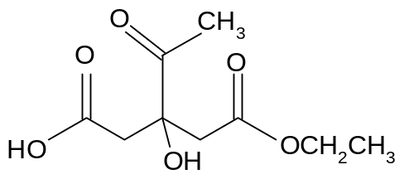
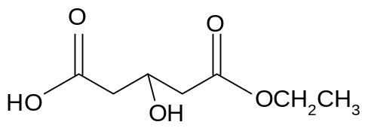

(i) Name four different functional groups present in the compound A.

(ii) Describe a simple test, stating the reagents and conditions and the expected results to distinguish between compound A and Compound B.
[3]

(c) The table below shows the melting points of the chlorides of
Period 3 elements.

Compound | Melting point / °C
Magnesium chloride | 701
Silicon chloride | −70

- State the formula of each of these chlorides.  (ii) Explain the variation in the melting points of these chlorides in terms of their structure and bonding.  (iii) Describe the reactions, if any, of each of these chlorides with  water, stating the approximate pH of any solution formed.  Write a balanced equation for any reaction that takes place.  [Total: 20 marks] | [7]

9 (a) (i) Define the term standard enthalpy change of combustion.

The combustion of hydrocarbons is an exothermic process. The heat evolved can be used to heat up a fixed volume of water in a calorimeter. The enthalpy change of combustion can then be determined by taking the temperature rise. In this experiment, the enthalpy change of combustion of ethanol was determined using the set up shown below:

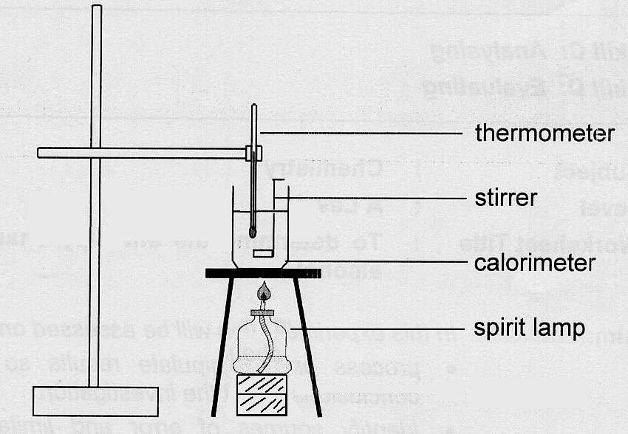

The following results were obtained:

Mass of water / g | 100
Original mass of spirit lamp + ethanol / g | 52.56
Final mass of spirit lamp + ethanol / g | 52.46
Original temperature of water / ºC | 18.5
Final temperature of water / ºC | 25.0
Specific heat capacity of water / J g⁻¹ K⁻¹ | 4.18

(ii) Write a balanced equation for the combustion of ethanol.

- Use these results to determine the experimental enthalpy change of
combustion for ethanol.

(iv) State one assumption you have made in your calculations.

(v) Use of the Data Booklet is relevant to this question. By considering the bonds formed and broken during the combustion of ethanol, calculate the theoretical enthalpy change of combustion of ethanol.

(vi) Suggest a reason for the difference in the experimental and theoretical
results that you have calculated.
[10]

(b) Ethylbenzene, whose structure is shown below, is an important intermediate in
the manufacture of poly(phenylethene), commonly known as polystyrene or
styrofoam.
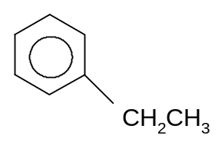

When ethylbenzene is treated with bromine under different conditions, two isomeric bromides, E and F, are formed.

(i) Suggest two conditions under which ethylbenzene can react with bromine, and in each case state the type of reaction undergone.

- E is inert towards hot aqueous potassium hydroxide solution.
- On refluxing E with acidified aqueous potassium manganate(VII) an acid X, C₇H₅BrO₂ is formed.

(ii) Draw the structural formula of E and X.
F reacts with hot alcoholic potassium hydroxide to give phenylethene, C₆H₅CH=CH₂,
- F reacts with hot aqueous potassium hydroxide to form G.
- G reacts with acidified potassium dichromate solution to give H,C₈H₈O.
- H reacts with 2,4-dinitrophenylhydrazine to give an orange precipitate but does not react with Fehling`s solution.

(iii) Draw the displayed formula of F.
(iv) Name of the type reaction by which F is converted to phenylethene.
(v) Explain, giving reasons, what is observed when G reacts with aqueous iodine in sodium hydroxide.
(vi) Explain why H reacts with 2,4-dinitrophenylhydrazine but H does not react with Fehling’s solution. [10]
[Total: 20 marks]

